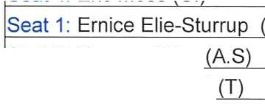
Majorca Isles
!
!
Seat | 4 : | Eric Moss (C. | :v.c
Seat | 2 : | Tamara Price (A S
Seat | 5: | Rayon Howard (T
Seat | 3 : | Timothy Fowler (A | S

Community Development District
Special Meeting Agenda !

Wednesday May 12, 2021
6:00 p.m.
1031 Ives Dairy Rd, Suite 228, Miami, FL. https://global.gotomeeting.com/join/312425405
1 (571) 317-3122; Access Code: 312-425-405

In accordance with Office of the Governor, Executive Orders authorizing the use of communications media technology, the Board of Supervisors and members of the public may attend and participate in the meeting utilizing the call-in information above.

- Roll Call

- Consideration of Resolution #2021-10 Electing Officers

- Consideration of Engagement Letter with Grau & Associates to perform the Audit for Fiscal Year Ending September 30, 2020

- Consideration of Assumption and Acceptance of Agreement for Walden Place II

- Approval of Requisition No. 9 for Acquisition of Completed Water and Sewer Facilities in Walden Place

- Selection of District Records Office Within Miami-Dade County

- Staff Reports
  - Attorney

  - Engineer

  - Manager
    - Designation of Regular Monthly Meeting Date, Time and Location
    - Discussion of Meeting Site

- Supervisors Requests and Audience Comments-Correspondence from Chairman

- Adjournment

Meetings are open to the public and may be continued to a time, date and place certain. For more information regarding this CDD please visit the website: http://www.maiorcacdd.com

